|  |  |  |  |  |  |
| --- | --- | --- | --- | --- | --- |
| 78 | 92 | 67 | 32 | 76 | 80 |

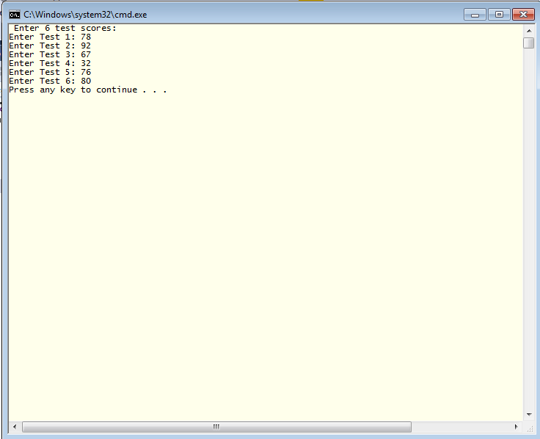Test Score 0 Test Score 1 Test Score 2 Test Score 3 Test Score 4 Test Score 5

//Henry Osei

#include <iostream>

using namespace std;

int main()

{

int tests[6]; // array declaration

int sum = 0;

float avg;

int max = 0;

//input test scores

cout << " Enter " << 6 << " test scores: " << endl;

for (int i = 0; i < 6; i++)

{

cout << "Enter Test " << i + 1 << ": ";

cin >> tests[i];

}

for (int i = 0; i < 6;i++)

cout << "All Test Scores---->" << tests[i] << endl;

cout << "*******************************************************" << endl;

cout << "First Test Score:" << tests[0] << endl;//First Test Score

cout << "****************************************************" << endl;

cout << "Last Test Score:" << tests[5] << endl;//Last Test Score

cout << "********************************************" << endl;

{

for (int i = 0;i < 6;i++)

sum = sum + tests[i];//Sum of all scores

}

cout << "The Sum------------>" << sum << endl;

cout << "************************************" << endl;

{

avg = (float)sum / 6;

cout << "The average---->" << avg << endl;

}

for (int i = 0; i < 6; i++)

{

tests[i] = tests[i] + 10;

cout << "New Test socre----->" << tests[i] << endl;

}

max = -9999999999999999;

for (int i = 0;i < 6;i++)

{

if (tests[i] > max)

{

max = tests[i];

}

}

cout << "max---->" << max << endl;

return 0;

}

